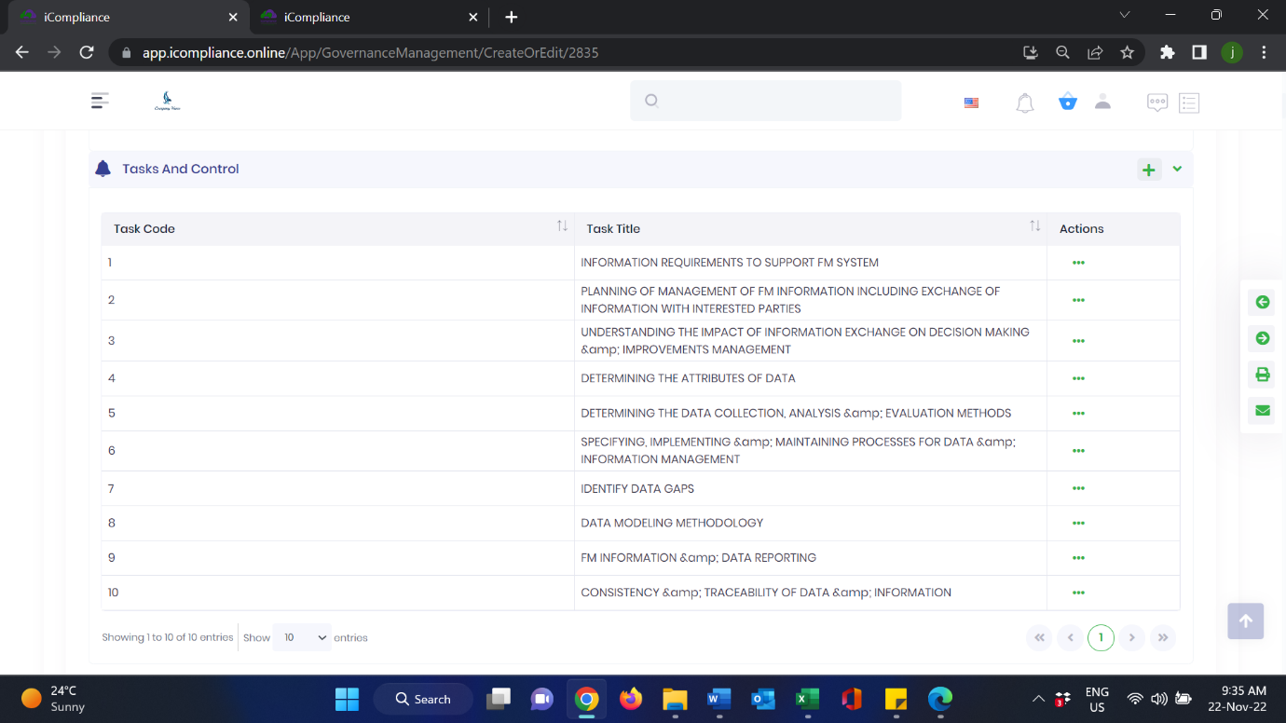ffdddddddddddddi-Governance

‘**&**’ symbol display error , task sub numbering, 1.1, 1.2, 1.3, etc…2.1, 2.2, 2.3, width of 1st column – consider narrowing to achieve balanced look. fgthfdsfgh

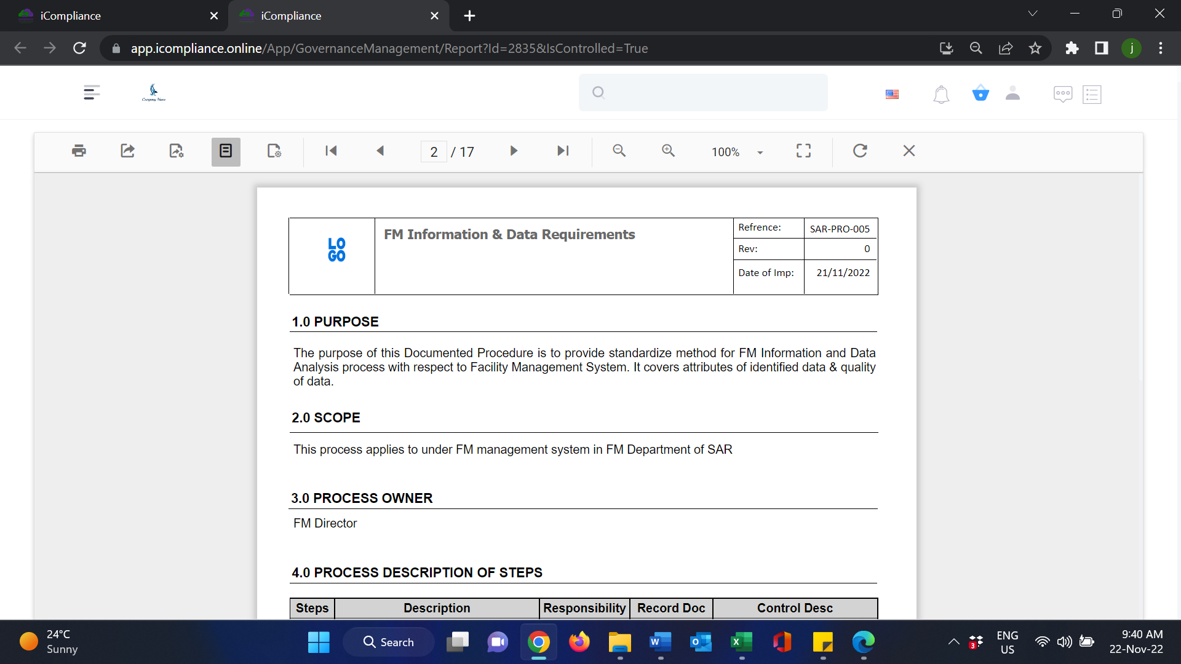

Spelling check - Reference

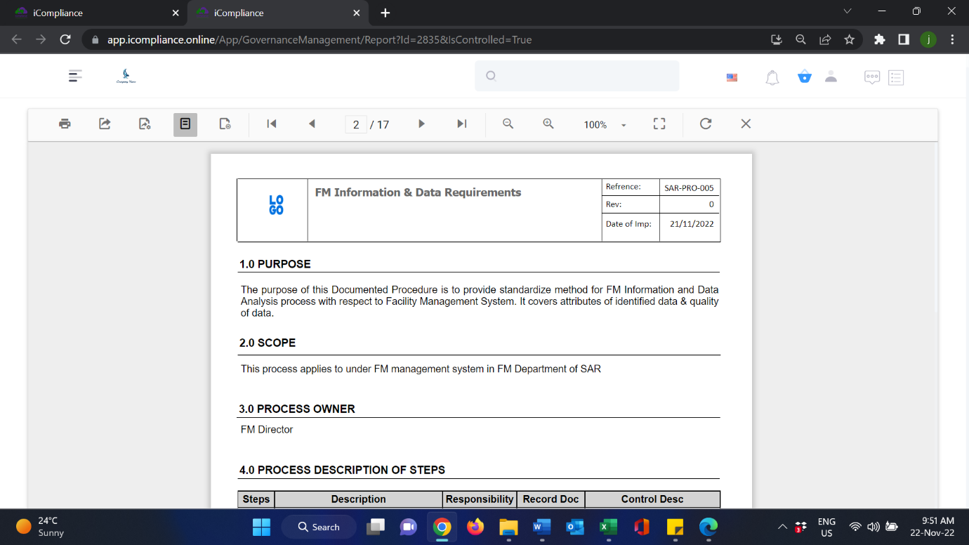

Navigation bar unresponsive? or is it my mouse? 😊

Consider increased contrast for vertical navigation bar?

Navigation bar not taking to next page – all related to view mode (if theres an option to navigate all pages using navigator)

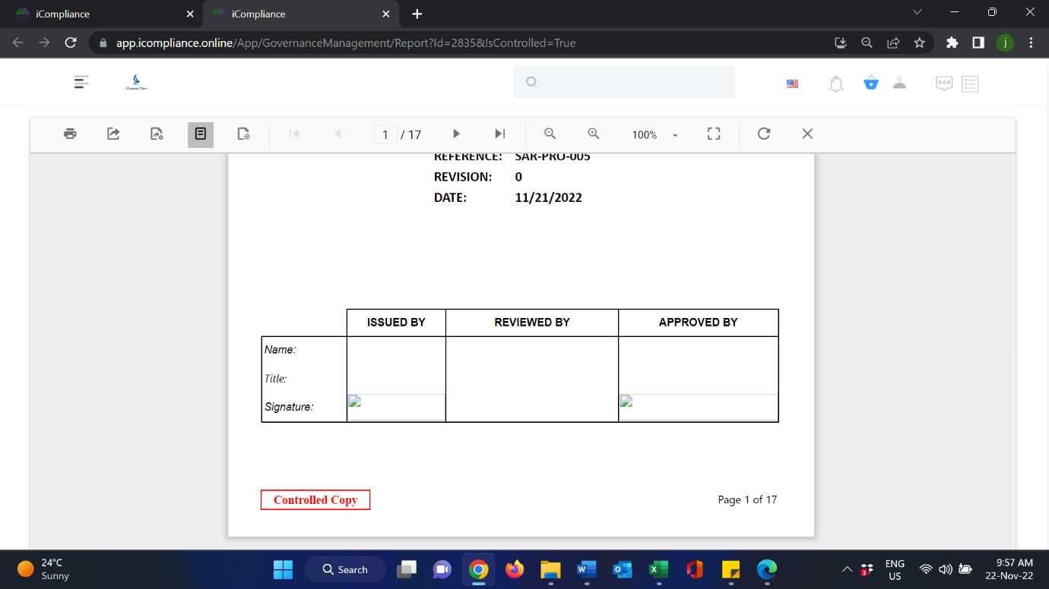

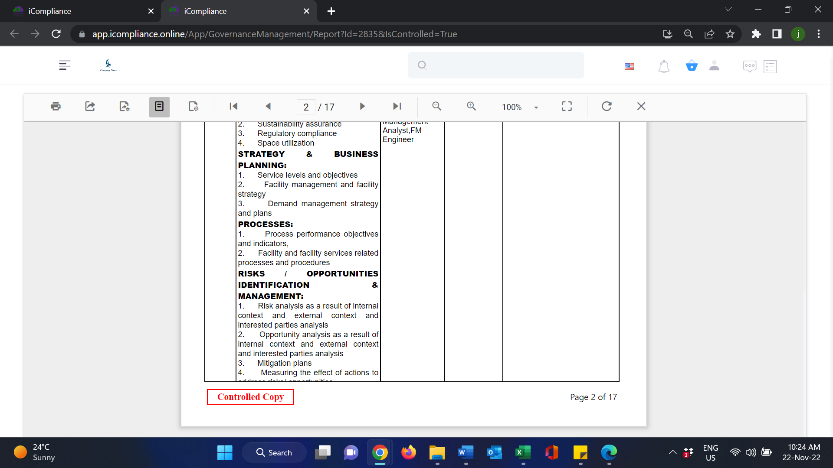

Word wrapping – content not visible, consider increasing width of description of steps column and decreasing control column width so that entire doc doesn’t run into several pages.

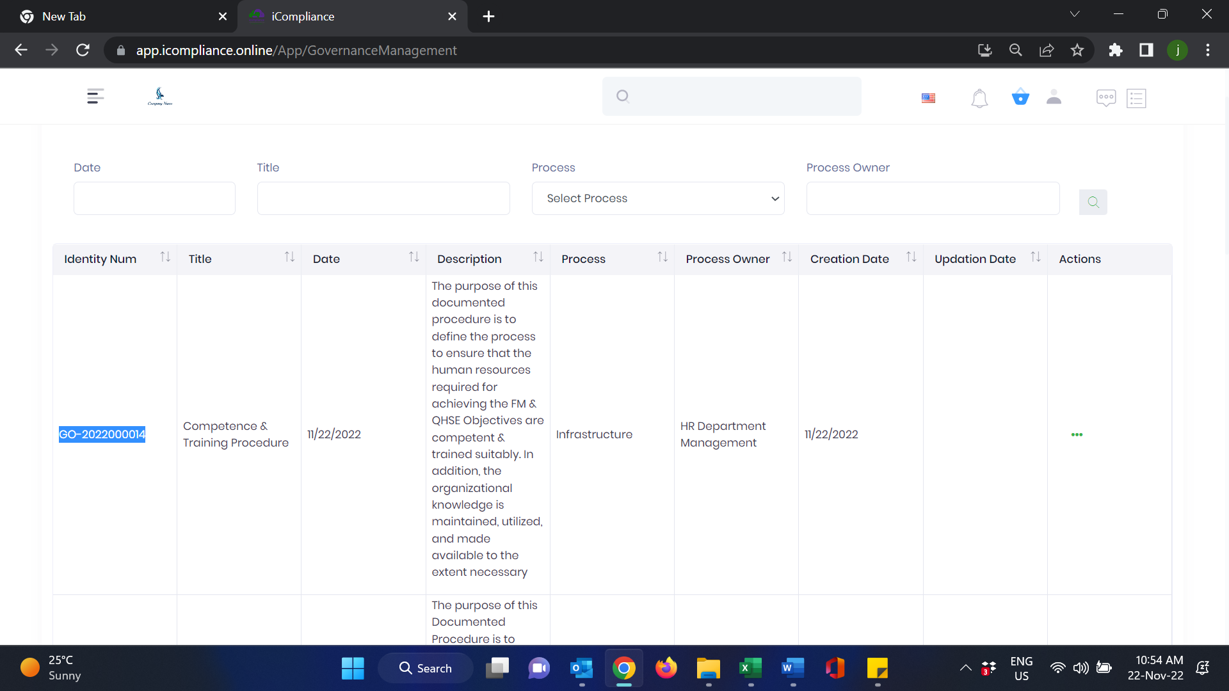

Pls activate the id no as hyperlink so as to access document

(Edit 23-11-22)- link active but not visible as hyperlink

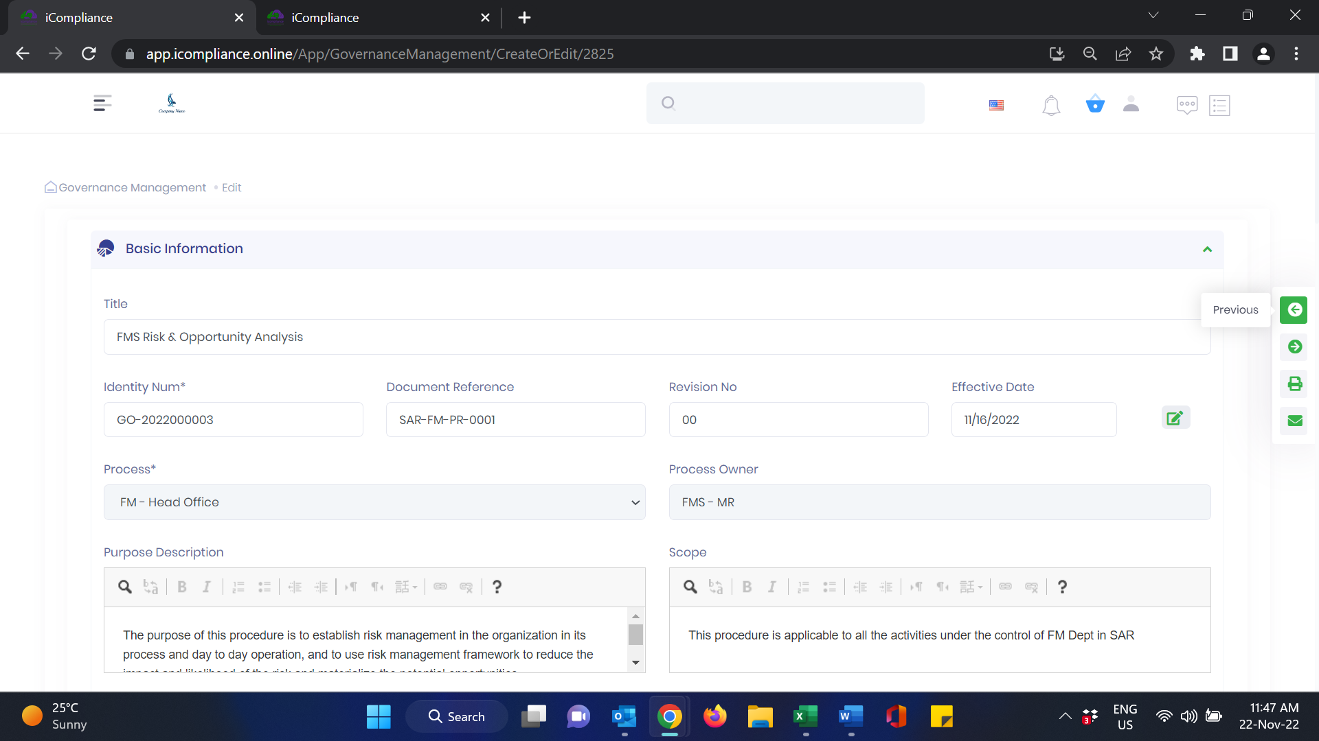

Previous – not functional

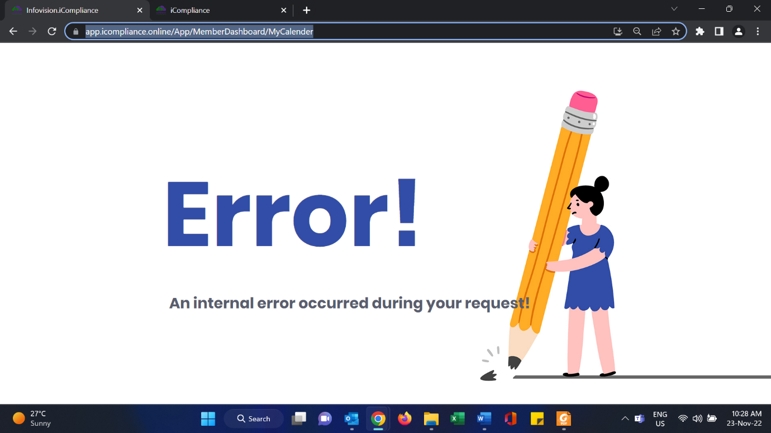

Calendar scheduling- can i-Audit be scheduled, and Audit plan reflected in calendar and reminders provided for the same? in dashboard? Mail to admin?

Auto population of Audit plan from the document (audit plan)the client has? (Query from SBG)

Reminders to follow- up on i-Incident and close out of i-Incident, corrective actions to be taken

(SBG- ticket- REF: demo)

CPA status to be renamed as NCR in i-Audit & i-Incident (SBG Ticket ref: demo teams meeting on 20th dec, 2022)